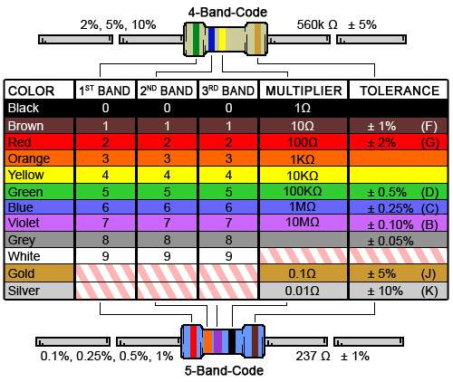

|  |  |  |  |  |  |
| --- | --- | --- | --- | --- | --- |
| Ejercicio | 1er Banda | 2da Banda | 3ta Banda | 4ta Banda | 5ta Banda |
| 1 | Marrón | Naranja | Violeta | Rojo |  |
| 2 | Rojo | Rojo | Rojo | Dorado |  |
| 3 | Violeta | Blanco | Naranja | Plata |  |
| 4 | Amarillo | Azul | Negro | Rojo |  |
| 5 | Naranja | Marrón | Amarillo | Marrón |  |
| 6 | Blanco | Verde | Dorado | Plata |  |
| 7 | Gris | Gris | Gris | Dorado |  |
| 8 | Violeta | Rojo | Plata | Dorado |  |
| 9 | Naranja | Rojo | Violeta | Marrón | Dorado |
| 10 | Azul | verde | Gris | Naranja | Plata |
| 11 | AMARILLO | CAFÉ | ROJO | NEGRO | Sin color |